- Transaction Analytics
QUESTION
Berapa total volume dan nilai transaksi per hari, minggu, dan bulan? Apa tren pertumbuhannya?
QUERY
SELECT
period_type,
period_start_date,
total_transactions,
total_amount,
avg_transaction_amount,
success_transactions,
failed_transactions,
pending_transactions,
previous_total_amount,
growth_amount_pct
FROM mart_transaction_analytics
ORDER BY
CASE
WHEN period_type = 'DAY' THEN 1
WHEN period_type = 'WEEK' THEN 2
WHEN period_type = 'MONTH' THEN 3
ELSE 4
END,
period_start_date;
OUTPUT
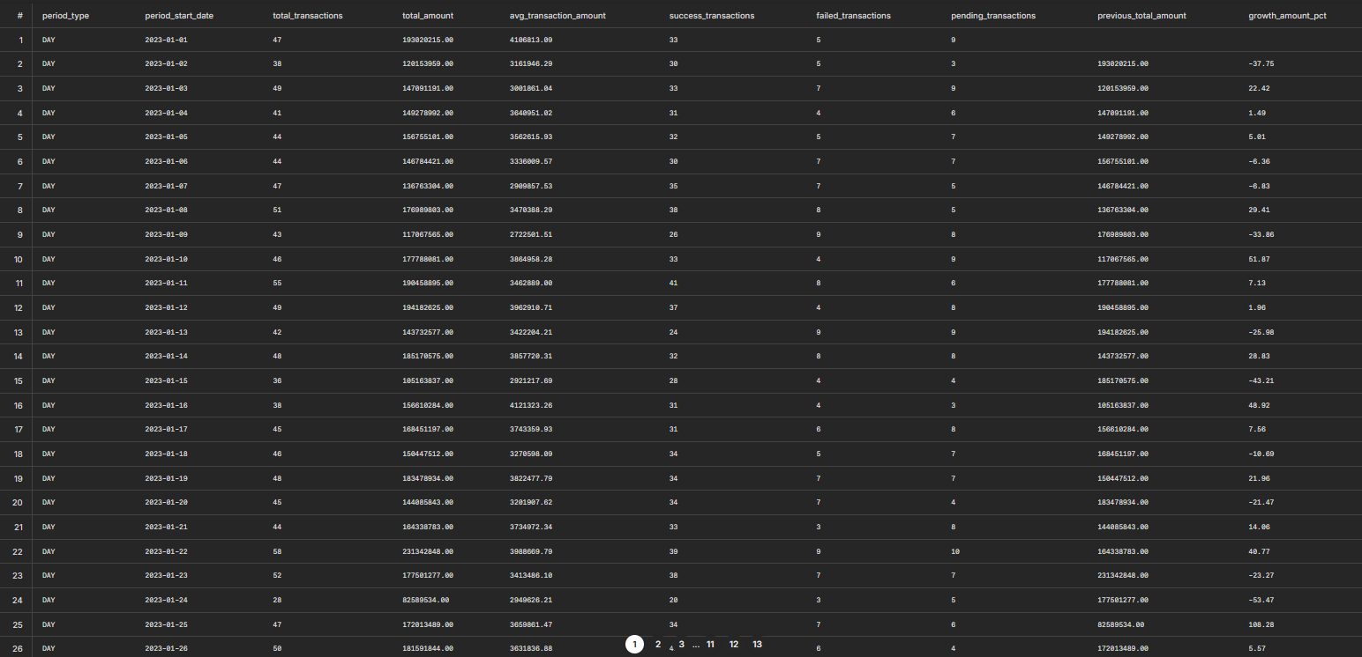

- Customer 360
QUESTION
Siapa nasabah paling aktif berdasarkan frekuensi dan nilai transaksi?
QUERY
SELECT
c.customer_id,
c.full_name,
c.segment,
COUNT(f.transaction_id) AS transaction_frequency,
SUM(f.amount) AS total_transaction_value,
RANK() OVER (ORDER BY SUM(f.amount) DESC) AS rank_by_value
FROM fact_transactions f
JOIN dim_accounts a ON f.account_id = a.account_id
JOIN dim_customers c ON a.customer_id = c.customer_id
GROUP BY c.customer_id, c.full_name, c.segment
ORDER BY total_transaction_value DESC
LIMIT 10;
OUTPUT
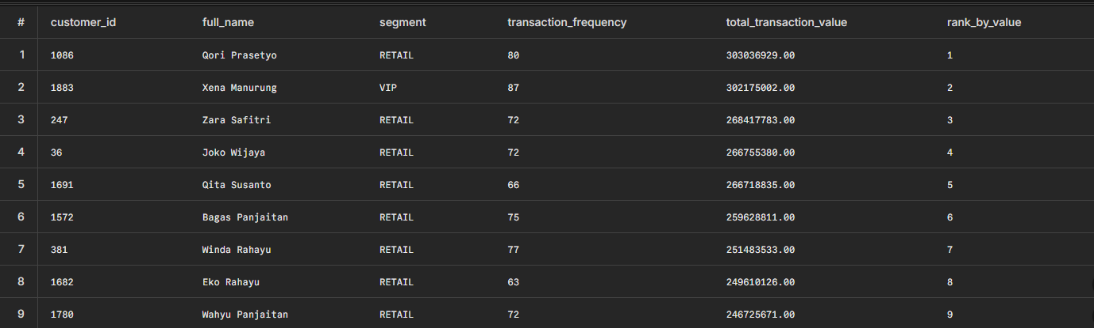
QUESTION
Bagaimana distribusi per segmen (VIP/Priority/VIP)?
QUERY
SELECT
c.segment,
COUNT(DISTINCT c.customer_id) AS total_customers,
COUNT(f.transaction_id) AS total_volume,
SUM(f.amount) AS total_value,
ROUND(AVG(f.amount), 2) AS average_ticket_size
FROM fact_transactions f
JOIN dim_accounts a ON f.account_id = a.account_id
JOIN dim_customers c ON a.customer_id = c.customer_id
GROUP BY c.segment
ORDER BY total_value DESC;
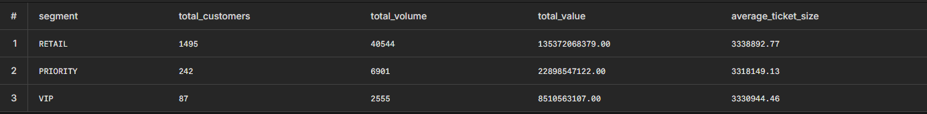

- Branch Performance
QUESTION
Cabang mana yang memiliki performa tertinggi berdasarkan jumlah transaksi dan total nilai transaksi per region?
QUERY
WITH branch_ranking AS (
SELECT
b.region,
b.branch_id,
b.branch_name,
COUNT(f.transaction_id) AS total_volume,
SUM(f.amount) AS total_value,
RANK() OVER (PARTITION BY b.region ORDER BY SUM(f.amount) DESC) AS rank_in_region
FROM fact_transactions f
JOIN dim_branches b ON f.branch_id = b.branch_id
GROUP BY b.region, b.branch_id, b.branch_name
)
SELECT
region,
branch_name,
total_volume,
total_value
FROM branch_ranking
WHERE rank_in_region = 1
ORDER BY total_value DESC;
OUTPUT
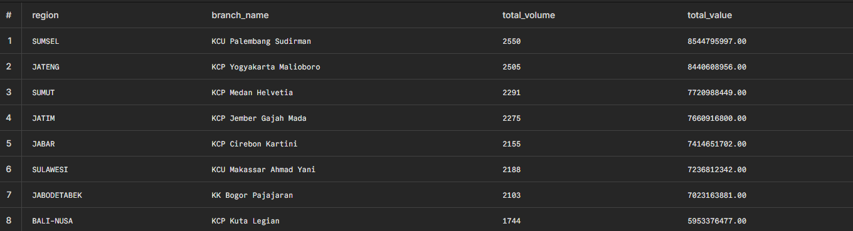

- Channel Analysis
QUESTION
Channel apa yang paling banyak digunakan nasabah?
QUERY
SELECT
d.year,
d.month_name,
ch.channel_name,
ch.channel_classification,
COUNT(f.transaction_id) AS volume,
SUM(f.amount) AS value,
-- Proporsi volume channel dibanding seluruh transaksi pada bulan tersebut
ROUND(COUNT(f.transaction_id) * 100.0 / SUM(COUNT(f.transaction_id)) OVER (PARTITION BY d.year, d.month), 2) AS volume_share_percentage
FROM fact_transactions f
JOIN dim_channels ch ON f.channel_id = ch.channel_id
JOIN dim_date d ON f.transaction_date = d.full_date
GROUP BY d.year, d.month, d.month_name, ch.channel_name, ch.channel_classification
ORDER BY d.year, d.month, volume DESC;
OUTPUT
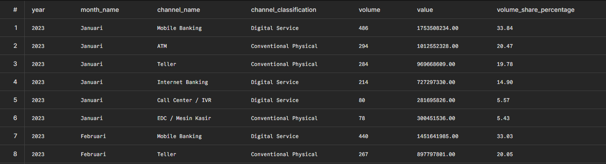

- Product Performance
QUESTION
Produk rekening mana yang menghasilkan volume transaksi dan saldo rata-rata tertinggi?
QUERY
SELECT
a.account_type,
a.product_name,
COUNT(f.transaction_id) AS total_transaction_volume,
SUM(f.amount) AS total_transaction_value,
ROUND(AVG(f.balance_after), 2) AS average_retained_balance
FROM fact_transactions f
JOIN dim_accounts a ON f.account_id = a.account_id
GROUP BY a.account_type, a.product_name
ORDER BY total_transaction_value DESC;
OUTPUT
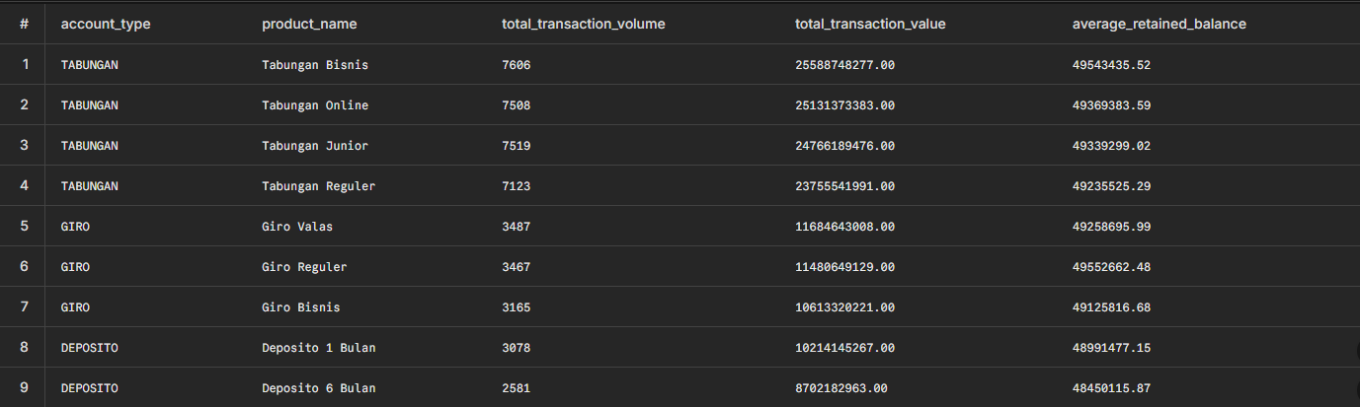

- Risk & Fraud Detection
QUESTION
Adakah transaksi anomali nilai sangat besar, frekuensi tidak wajar, atau status FAILED berulang yang perlu diwaspadai?
QUERY
SELECT
f.transaction_date,
c.customer_id,
c.full_name,
COUNT(f.transaction_id) AS total_failed_attempts
FROM fact_transactions f
JOIN dim_accounts a ON f.account_id = a.account_id
JOIN dim_customers c ON a.customer_id = c.customer_id
WHERE UPPER(f.status) = 'FAILED'
GROUP BY f.transaction_date, c.customer_id, c.full_name
HAVING COUNT(f.transaction_id) >= 5
ORDER BY total_failed_attempts DESC;
OUTPUT
